
Company
Logotype

Cone Beam Computed Tomography- Report



Porur Dental X-rays & CBCT

Patient Name : Mr. Selvaraj | Date of Report : 13.05.2024
Age/ Gender : 64 years/ Male | Region of Interest : CBCT Full Skull
Referring doctor: Denplant Dental care | Indication : Implant assessment
Clinical Notes: Nil
PATIENT INFORMATION

CBCT- Full Skull provided
CBCT – IMAGE DETAILS

RADIOGRAPHIC INTERPRETATION

- Complete loss of crown and root structure in relation to 18, 25, 26, 27, 28, 37, 47, 48.
- The alveolar ridge in relation to the maxillary and mandibular alveolar ridge is present with normal trabecular pattern.
- In 36, hyperdense restorative material involving the crown, extending upto the apical third of the roots with presence of furcal hypodensity.
- Generalized bone loss extending upto the middle third of roots is evident.

IMPLANT ASSESSMENT

 | 25 region | 26 region | 27 region
Sub-Crestal (in mm) | 7.3 | 10.5 | 12.9
Mid- Crestal (in mm) | 7.6 | 10.2 | 15.2
Distance between the alveolar ridge and floor of the maxillary sinus (in mm) | 14.8 | 10.7 | 10.1

 | 36 region | 47 region
Sub-Crestal (in mm) | 6.9 | 6.9
Mid- Crestal (in mm) | 8.3 | 8.3
Distance between alveolar ridge and the inferior alveolar nerve canal (in mm) | 10.6 | 10.6
Distance between alveolar ridge and the inferior border of mandible (in mm) | 27.6 | 27.6

RADIOGRAPHIC IMPRESSION

- Partially edentulous maxillary and mandibular arch.

Kindly correlate with clinical findings

IMAGES FOR REFERENCE

RECONSTRUCTED PANORAMIC VIEW

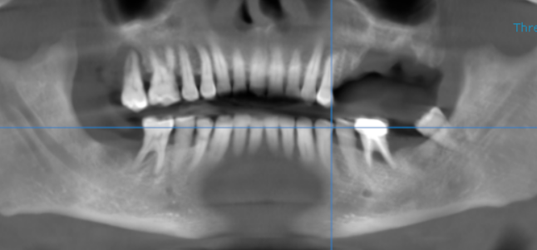

3-DIMENSIONAL VIEW
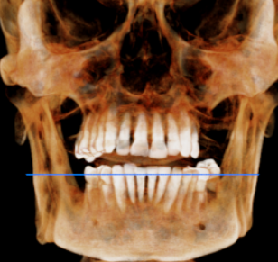

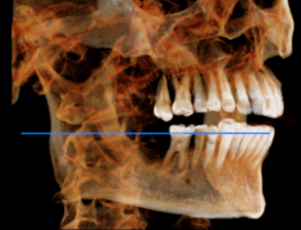
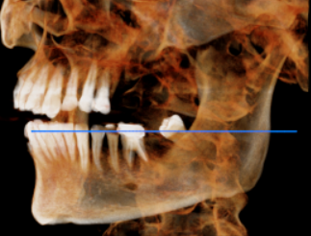

CROSS SECTIONAL VIEW

25 region | 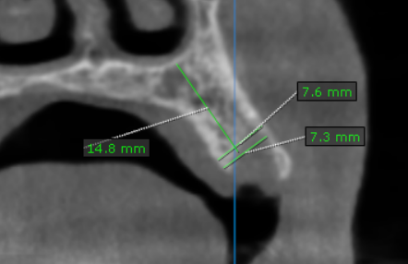
26 region | 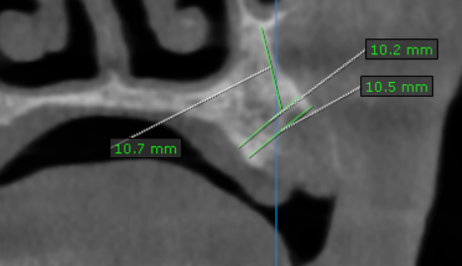
27 region | 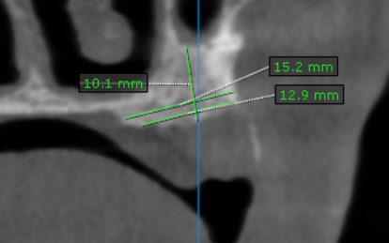
36 region | 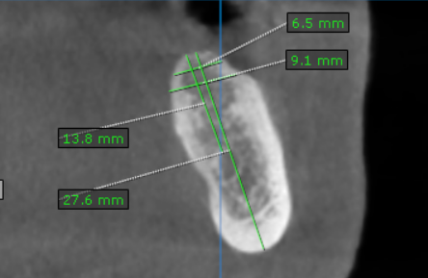
47 region | 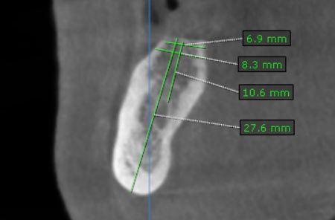

**** End of report ****

